**Experiment 5**  **Date**: 13/03/2023

Aim:

Familiarization of Linux Commands

Course Outcome(CO2):

Perform system administration task

Procedure:

1. read :- Read content of one line of input into a variable

$read

echo $REPLY :- To print the input from the default variable

Output:

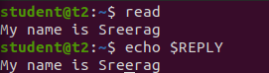

echo $REPLY :- To print the input from the default variable

* 1. read var1 var2 var3 :- To read into specific variables

$read var1 var2 var3

$echo “[$var1][$var2][$var3]”

Output:

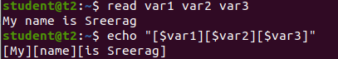

* 1. read input \ :- To read multiple lines

$read

My \

name is \

Sreerag

Output:

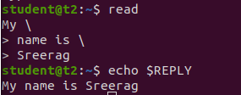

* 1. read -p :- Prompt text from user

$read -p “Enter your name”

$echo “my name is $REPLY”

Output:

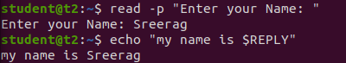

* 1. read -n :- Specify limit

$read -n 6 -p “Enter six characters only”

Output:



* 1. read -s :-For security. Hides input

$read -s -p “Enter the password: “

Output:



1. wc :- Word count display number of lines, number of words, number of bytes and file name

$wc file.txt

Output:



* 1. wc -l :- Display number of lines

$wc -l file.txt

Output:



* 1. wc -m :-Display number of bytes

$wc -m file.txt

Output:



* 1. wc -c :- Display number of characters

$wc -c file.txt

Output:



* 1. wc -w :-Display number of words

$wc -w file.txt

Output:



* 1. wc -L :- Displays length of longest line

$wc -L file.txt

Output:



1. more :- It is similar to cat to display the content. The difference is that in case of larger files, cat command output will scroll off your screen while more command display output one screenful at a time.

$more finalfantasy.txt

Output:

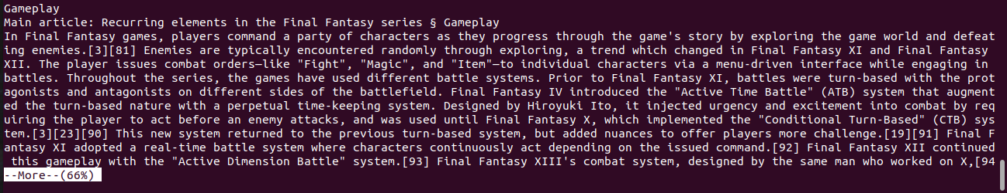

* 1. more +15 file.txt :- Will display content after the specified number of lines

$more +15 finalfantasy.txt

Output:

￼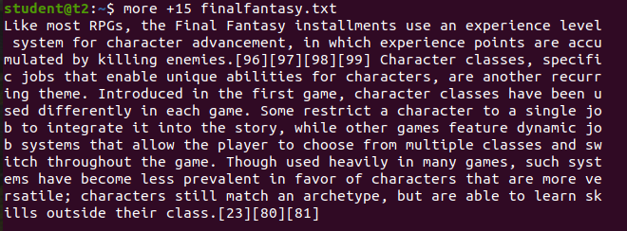

* 1. more +/pattern file.txt :- Search and navigate towards a particular string and view all the instances.

$more +/classes finalfantasy.txt

Output:

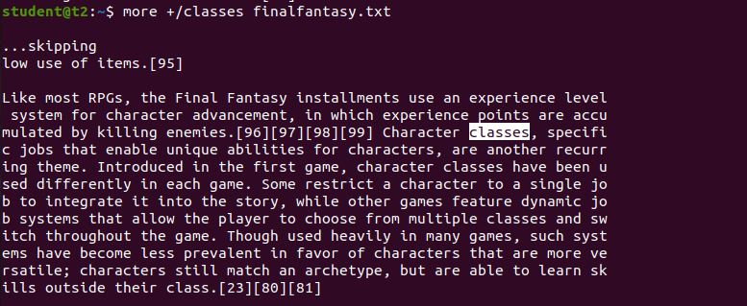

* 1. more -p file.txt :- Clear the whole screen and then display the text.

$more -p file.txt

Output:

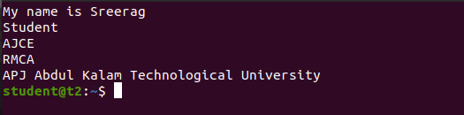

* 1. more -d file.txt :- Helps the user to navigate according to instructions, [space to continue and ‘q’ to quit]

$more -d finalfantasy.txt

Output:

